24.76: a) The force between the two parallel plates is:
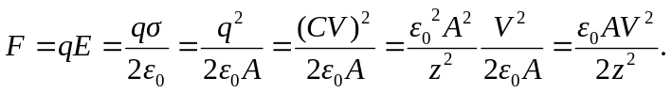
b) When 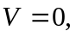 the separation is just 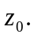So:
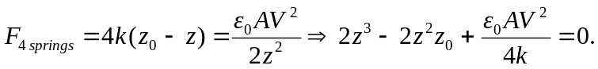
c) For
d) Stable equilibrium occurs if a slight displacement from equilibrium yields a force back toward the equilibrium point. If one evaluates the forces at small displacements from the equilibrium positions above, the 1.014 mm separation is seen to be stable, but not the 0.537 mm separation.

